# Cisco Switch Commands Cheat Sheet (CLI)

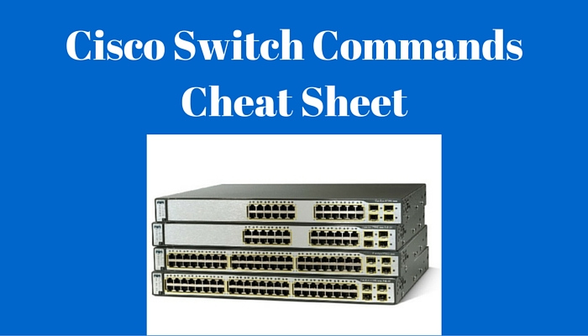

Cisco switches can be used as plug-and-play devices out of the box but they also offer an enormous amount of features. Although the main purpose of the switch is to provide inter-connectivity in Layer 2 for the connected devices of the network, there are myriad features and functionalities that can be configured on Cisco Switches.

In the following Cisco Switch Commands Cheat Sheet, I have tried to include the most important and frequently-used CLI commands that Cisco professionals encounter in real world networks. I know that the list is not exhaustive but I believe that the most useful commands are included.

The following commands will work on most Cisco switch models such as 4500, 3850, 3650, 2960, 3560 etc.

Setting Host Names

TestSwitch#config t

*[Entering into Global Configuration Mode]*

TestSwitch(config)#hostname MySwitch

*[Enter the hostname of the switch]*

MySwitch(config)#

Setting login credentials:

MySwitch(config)#username *admin*password *csico1234*

*[create username and password for logging in to the switch]*

MySwitch(config)#enable secret *test*

*[Sets encrypted secret password using MD5 algorithm. This is the enable password that you will be asked to enter when trying to enter into “enable” mode]*

MySwitch(config)#service password-encryption

*[Encrypt all the passwords using MD5]*

Console Access:

MySwitch(config)#line con 0

*[Enter into line console mode]*

MySwitch(config-line)#password *test3*

*[Set password on console]*

MySwitch(config-line)#login

*[Enable password checking on console]*

SSH/Telnet Access to the switch:

MySwitch(config)#line vty 0 4

*[Enters line vty mode for all five virtual ports]*

MySwitch(config-line)#transport input ssh

*[Enable SSH]*

MySwitch(config-line)#transport input telnet

*[Enable telnet]*

Report this ad

MySwitch(configiline)#password test3

*[Set password]*

Setting IP Address (To allow remote access to the switch):

MySwitch(config)#interface vlan1

*[Enters vlan1, the native vlan]*

MySwitch(config-if)#ip address 192.168.1.2 255.255.255.0

*[Set IP address for management]*

MySwitch(config-if)#exit

MySwitch(config)#ip default-gateway 192.168.1.1

*[Exit path for the switch – gateway IP]*

Interface description

MySwitch(config)#interface g0/1

MySwitch(config-if)#description *TO SERVER*

Duplex and Speed Settings

MySwitch(config)#interface g0/1

MySwitch(config-if)#speed 10

*[Force 10Mbps Speed]*

MySwitch(config-if)#speed 100

*[Force 100Mbps Speed]*

MySwitch(config-if)#speed auto

*[Enable auto speed configuration]*

MySwitch(config-if)#duplex auto

*[Enable auto duplex configuration on switch port]*

MySwitch(config-if)#duplex full

*[Enable full duplex configuration on switch port]*

MySwitch(config-if)#duplex half

*[Enable half duplex configuration on switch port]*

Setting Web-based interface for configuration (GUI):

MySwitch(config)#ip http server

*[Enable HTTP server]*

MySwitch(config)#ip http port 80

Save current configuration

MySwitch(config)# copy running-config startup-config

Verification Commands:

TestSwitch#show version

*[Displays software and hardware information]*

TestSwitch#show running-config

*[Displays currently running configuration in DRAM]*

TestSwitch#show start

*[Displays configuration in NVRAM which will be loaded after reboot]*

TestSwitch#show flash:

*[Displays Flash memory information]*

TestSwitch#show boot

*[Displays boot path and image]*

TestSwitch#show clock

*[Displays the system clock]*

TestSwitch#show interfaces

*[Displays all interfaces configuration and status of line]*

TestSwitch#show interface status

*[Displays interface status, vlan, Duplex, Speed and type]*

TestSwitch#show cdp neighbors

*[Displays information of connected devices]*

TestSwitch#show cdp neighbors detail

*[Displays detailed information of connected devices]*

TestSwitch#show mac address-table

*[Displays current MAC address forwarding table and which MAC is learned on each switch port]*

Resetting the Switch

TestSwitch#erase startup-config

*[Delete start-up file from NVRAM]*

TestSwitch#reload

*[Reboot the Switch]*